# CS 255 System Design Document Template

## UML Diagrams

### UML Use Case Diagram

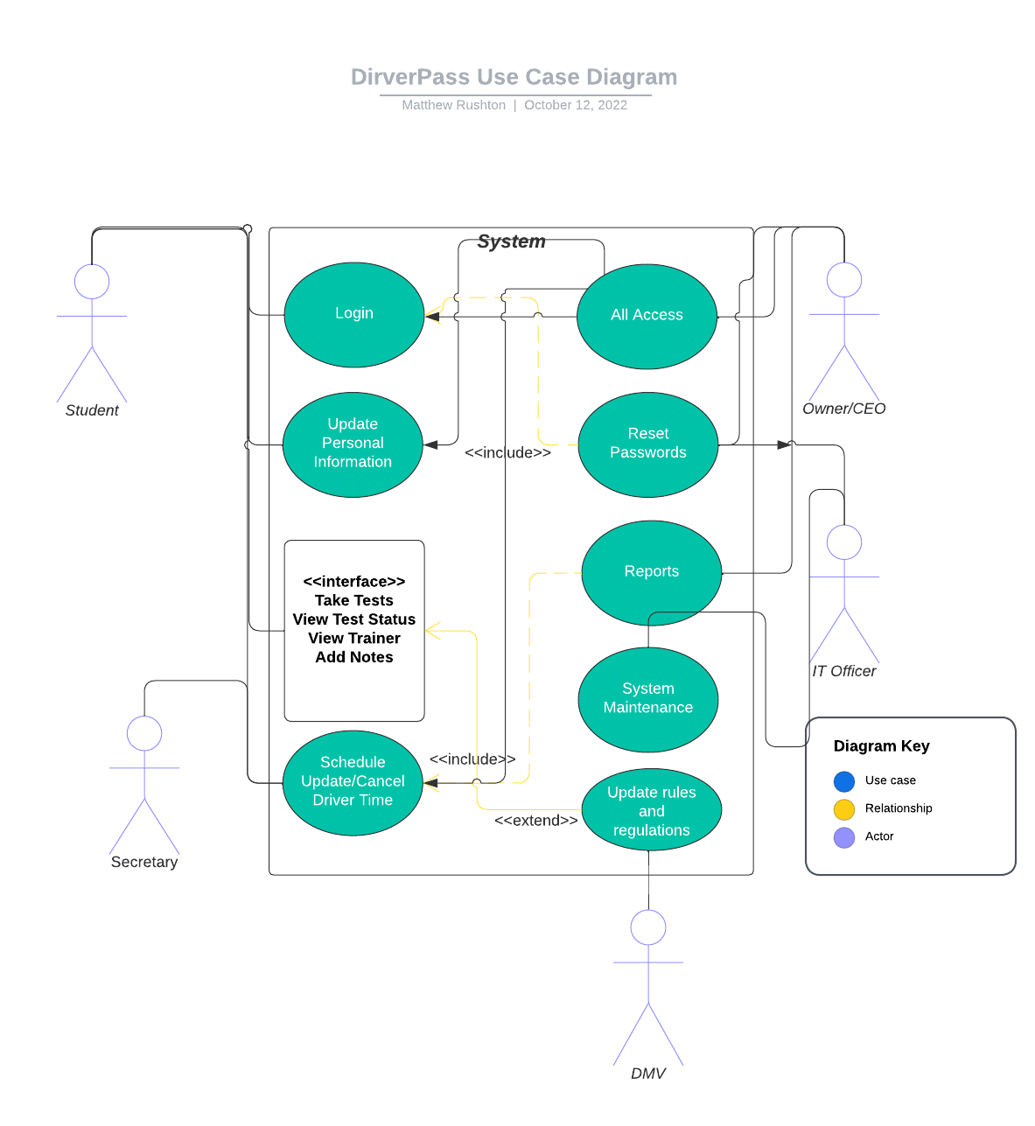

### 

### Activity Diagrams

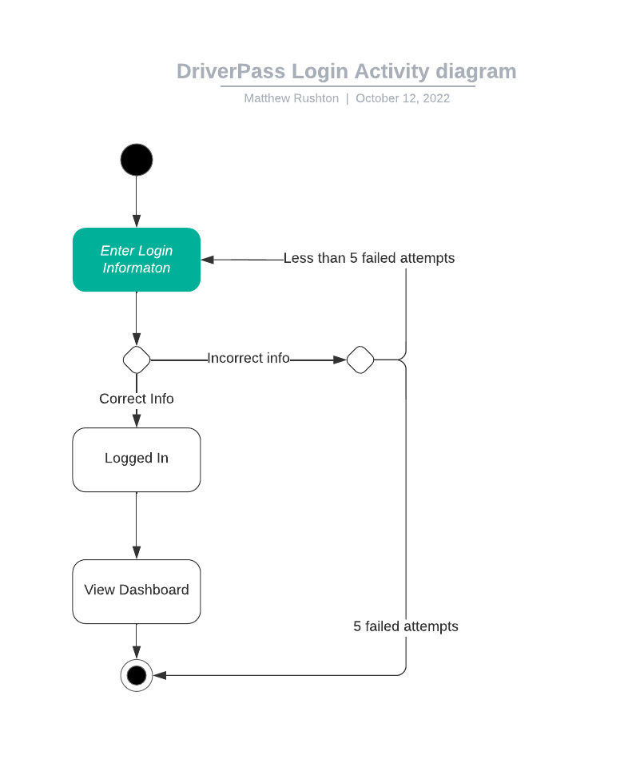

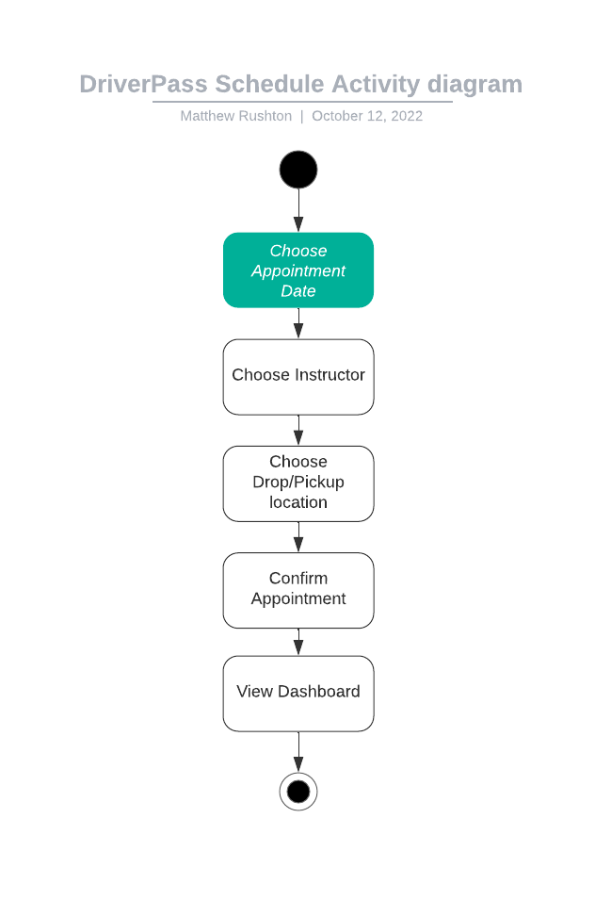

### UML Sequence Diagram

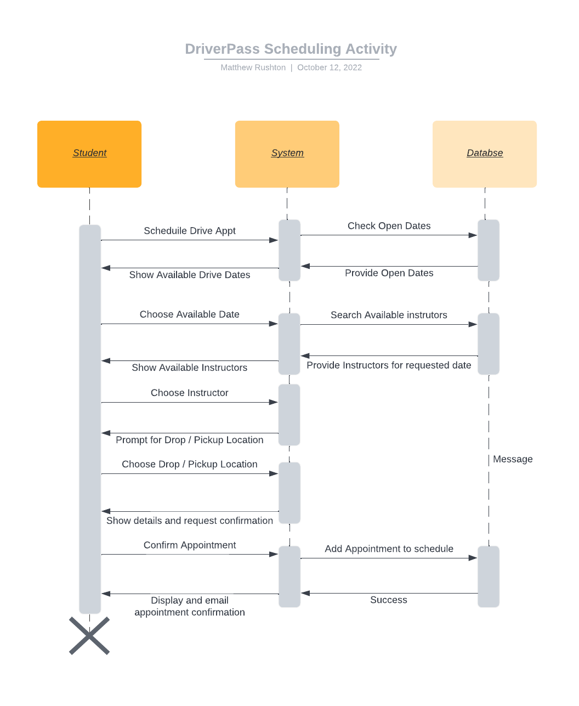

### UML Class Diagram

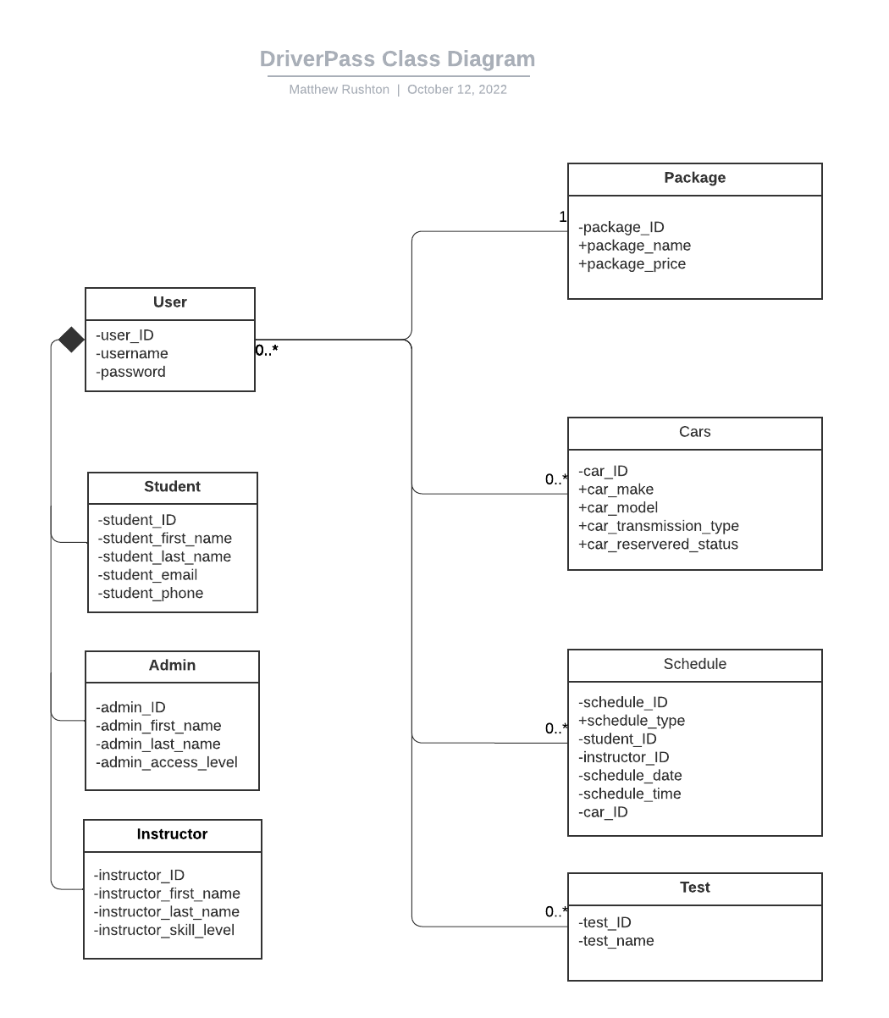

## Technical Requirements

The application will require a database in order to store appointments and allow users to view information pertaining to their tests, appointments and their instructors.

Any operating system is acceptable as this application will be accessed view web browser and is compatible with Chrome, Safari and Firefox for mobile.

Administrators will need access to all features so they can reset passwords, update user information and run/view reports.

Users will include students, the DriverPass secretary, administrator and instructors, each with a different access level to the website. Instructors can be view only to check their schedules and will contact the admin for their availability. Users will update their own information and have access to purchase packages, make appointments, and view their statuses.

When users login, they will get 5 attempts. On the 5th failed attempt the system will lock the user’s account and they will have to reset their password in order to access DriverPass again.

For appointment scheduling, the user should be shown available appointment date, then based of chosen date, choose the instructors available for that date. After choosing their date and instructor, they will be asked for a pickup / drop off location, then to confirm their information. After confirmation, an email confirmation will be sent and the app will display the confirmation information.

Users should be able to see their tests in progress and the status of already taken tests as well as their instructor information, notes and any special provisions. Admins should be able to view the same information for the users.

Cars will be assigned on rotation basis for each appointment.